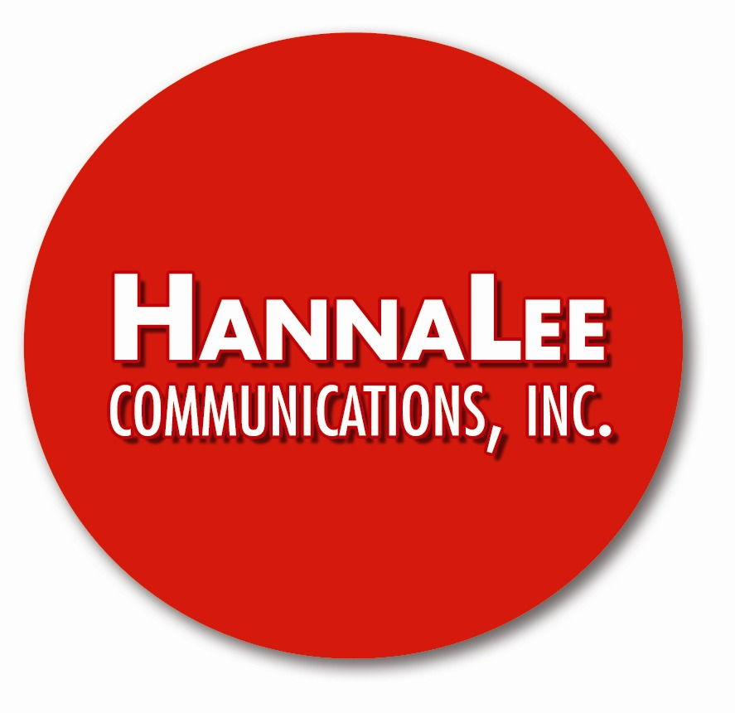

Media Contacts:
Hanna Lee
Hanna Lee Communications, Inc.
212-527-9969 (office) / 646-752-1526 (cell)
hanna@hannaleecommunications.com

FOR IMMEDIATE RELEASE

Hanna Lee Communications, Award-Winning PR Agency,
Announces First Book Deal: The Japanese Art of the Cocktail
with Houghton Mifflin Harcourt

Co-Authors Masahiro Urushido of Katana Kitten and Michael Anstendig,
a Freelance Journalist, Team Up; Spring 2021 Publishing Date

NEW YORK, July XX, 2020—Hanna Lee Communications, an award-winning PR and marketing agency specialized in hospitality, travel and luxury lifestyle, today announces its first book deal, The Japanese Art of the Cocktail. Scheduled for publication in Spring 2021 by Houghton Mifflin Harcourt (HMH), the book is co-authored by Masahiro Urushido, the bar star who leads Katana Kitten, and freelance journalist Michael Anstendig, who writes about food and drink.

The agency identifies authors and compelling subjects to bring new hospitality and lifestyle books to life. Promotional efforts—including PR and digital marketing—are built into every phase of the publishing process to create maximum visibility and ensure success. It is an outgrowth of the agency’s “Meet the Inspiring Authors” series of book-signing events that has promoted more than two dozen authors to date. It is part of HLC Innovation 15, an ongoing initiative to pioneer new ways of brand building and storytelling, while celebrating the agency’s 15th anniversary.
“We are proud to announce Masahiro Urushido and Michael Anstendig as our agency’s first co-authors,” says Hanna Lee, President and Founder, Hanna Lee Communications, Inc. “We have been fans of Masahiro for many years and got to work with him as a client when we helped launch Katana Kitten. Masahiro’s moving bartending journey inspired us to tell his unique story. Michael visited Japan multiple times and has long been passionate about its food and beverage culture. It is really exciting to see them collaborating and creating something meaningful and lasting. On the publishing house side, we are partnering with Houghton Mifflin Harcourt based on our multi-year working relationship and our agency’s publicizing two of their successful cocktail books, The Dead Rabbit Drinks Manual and The Dead Rabbit Mixology & Mayhem.”

Urushido is co-owner of Katana Kitten, a Japanese-American bar in New York City that recently ranked #14 and “Best New Opening” on the World’s 50 Best Bars list and earned “Best New American Cocktail Bar” at 2019 Tales of the Cocktail, some of the industry’s most coveted accolades. The bar has become one of New York City’s most visited drinks destinations.

Anstendig covers food and drink and his work has appeared in the New York Times, The New York Observer, The Daily News, Time Out New York and Nation’s Restaurant News. He has reviewed more than 200 restaurants for www.nymag.com and cocktail books for www.TalesOfTheCocktail.org. Anstendig is also a contributor to David Wondrich’s upcoming Oxford Guide to Spirits and Cocktails and also taught writing at New York University for more than a decade.

About Hanna Lee Communications, Inc.
Hanna Lee Communications, Inc. is an award-winning PR and marketing agency specialized in hospitality, travel, bars, restaurants, spirits and luxury lifestyle. The agency only represents products and companies that it believes in and who have a vision of changing the world.

This outlook drives its well-acknowledged excellence that has been recognized with more than 40 national and international awards and accolades, including “Best Branding,” “Best Media Relations,” “PR Innovator of the Year,” “Best Social Media Campaign” and “Best Press Release Writing.” The agency’s Digital Studio Division complements its PR campaigns through social media, photography and videography.

Hanna Lee Communications has helped build national and global brands that include: The Dead Rabbit; BlackTail; Danny Meyer’s Cedric’s at The Shed at Hudson Yards and Porchlight; Major Food Group’s The Polynesian, Santina, Dirty French and The Pool Lounge; The Times Square EDITION/John Fraser Restaurants; Armani / Ristorante 5th Avenue by Giorgio Armani; RedFarm; Dear Irving; Consortium Holdings’ Raised by Wolves and Polite Provisions (San Diego); Fever-Tree; BERTOUX Brandy; Sombra Mezcal; iichiko Saiten Shochu; Ten To One Rum and more.

To celebrate its 15th anniversary, the agency is launching HLC Innovation 15. It consists of pioneering initiatives that redefine storytelling and brand building. To date, they include the HLC Digital Studio Division, HLC Global Bartender Travel Scholarship, HLC Book Incubator and HLC Trailblazing Women Series.

For more information, follow us on Instagram and Twitter at @hannaleepr, “like” us on Facebook at www.facebook.com/HannaLeeCommunications and visit www.hannaleecommunications.com.

# # #

