Peraton: Supporting Missions with Heart
The American Heart Association (AHA) Heart Walk isn’t just an annual event for Peraton—it’s a cause that runs deep within our very culture. For nearly a decade, our commitment to the AHA has been unwavering, with participation dating back to 2015. For many years, we’ve raised more than $3 million, donated countless volunteer hours, and seen hundreds of our employees come together in a shared mission to help save lives and promote heart health. Our journey with the AHA is not just about fundraising; it’s a reflection of the profound personal connections many of our team members have to this cause.
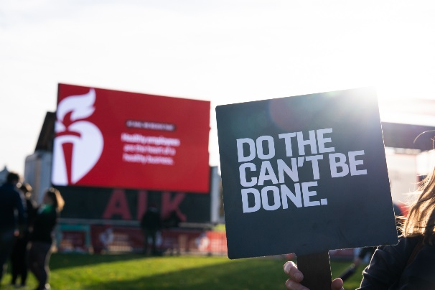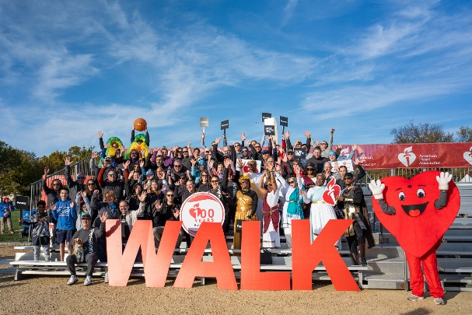
In 2024, Peraton's involvement reached new heights, setting a fundraising record of more than $85,000 for the Heart Walk. That achievement wasn’t just a financial milestone—it represented the collective spirit of our employees, many of whom had a personal stake in supporting heart health. As Joe Cirillo, manager of employee engagement and advocacy, proudly shared, “We had employees across the U.S. participating in their local Heart Walks. In the D.C. metro area, we were recognized as one of the top 10 companies and achieved the most steps for the Move More Activity Challenge.” The pride was evident, but what truly stood out was the unity and passion driving this effort—a shared commitment to a cause that goes beyond the workplace.
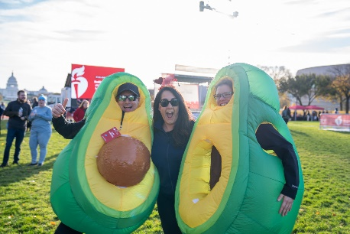
The road to success was not without challenges. Organizing the event in multiple locations, engaging employees who had different levels of fundraising familiarity, and moving beyond traditional methods all required new strategies and creative thinking. The biggest hurdle? Getting executives to step outside their comfort zones. Joe and his team gently pushed boundaries, and with a little persuasion, the company’s executives participated in a Pie-in-the-Face event to boost donations. Their willingness to be part of something fun and unconventional brought fresh energy to the campaign, as did the involvement of brand ambassadors throughout the company who helped spread the word far and wide.
The impact of Peraton’s support goes beyond the Heart Walk itself. In addition to participating in the walk, we’ve hosted CPR events at our Fairfax County offices, attracting more than 100 participants to learn lifesaving skills. We also celebrated National Wear Red Day, on Feb. 7, to raise awareness about heart attacks and encourage heart health. These efforts have been part of a broader, year-round commitment to supporting AHA and empowering employees to become role models within their communities.
Unbeknownst to many, Joe has a personal connection to the cause that runs deeper than his role as event coordinator. Within the past year, Joe learned that he has a heart defect—an abnormality discovered during his routine physical. This revelation, combined with his family’s history of heart disease, only strengthened his passion for AHA’s work. His wife, a cardiac nurse focused on heart research, has been an invaluable resource of wisdom and empathy along his journey. And, his maternal grandfather’s death from a heart attack only reinforced the urgency of this cause, making Joe's leadership even more impactful.
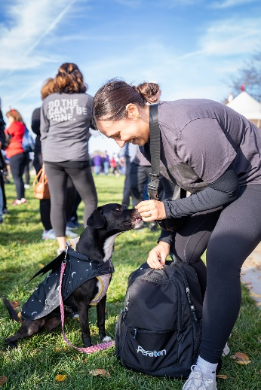
Reflecting on the company’s involvement, Joe said, “AHA is doing great work, not only to spread awareness but also on the legislative front. Now, in Virginia, high school students are required to be CPR certified before they graduate—creating a network of lifesavers.” It’s clear that for Joe, for Peraton, and for so many of the employees, the work we’re doing with AHA is much more than an event—it’s a cause that saves lives and strengthens our community.
From our early involvement in the Heart Walk to our record-breaking achievements in 2024, Peraton's support for the American Heart Association has grown into something that transcends fundraising. It’s become a part of the company’s DNA, driven by personal stories, meaningful engagement, and a collective desire to make a lasting impact on heart health. And with every step we take, we’re reminded of the lives we’re touching—both inside and outside of our company walls.
“From generous donations to memorable fundraisers like getting pied in the face, Peraton employees showed incredible spirit,” said Matt McQueen, Peraton’s executive sponsor for the American Heart Association and chief communications and engagement officer. “As AHA marks its 100-year anniversary, we’re honored to stand by their mission for a future free from heart disease.”
