The Rosendin Foundation Ignites Construction Passion with Unique Summer Camp Experience
TRF Camp Build engages and educates, fostering the joy of building and craftsmanship
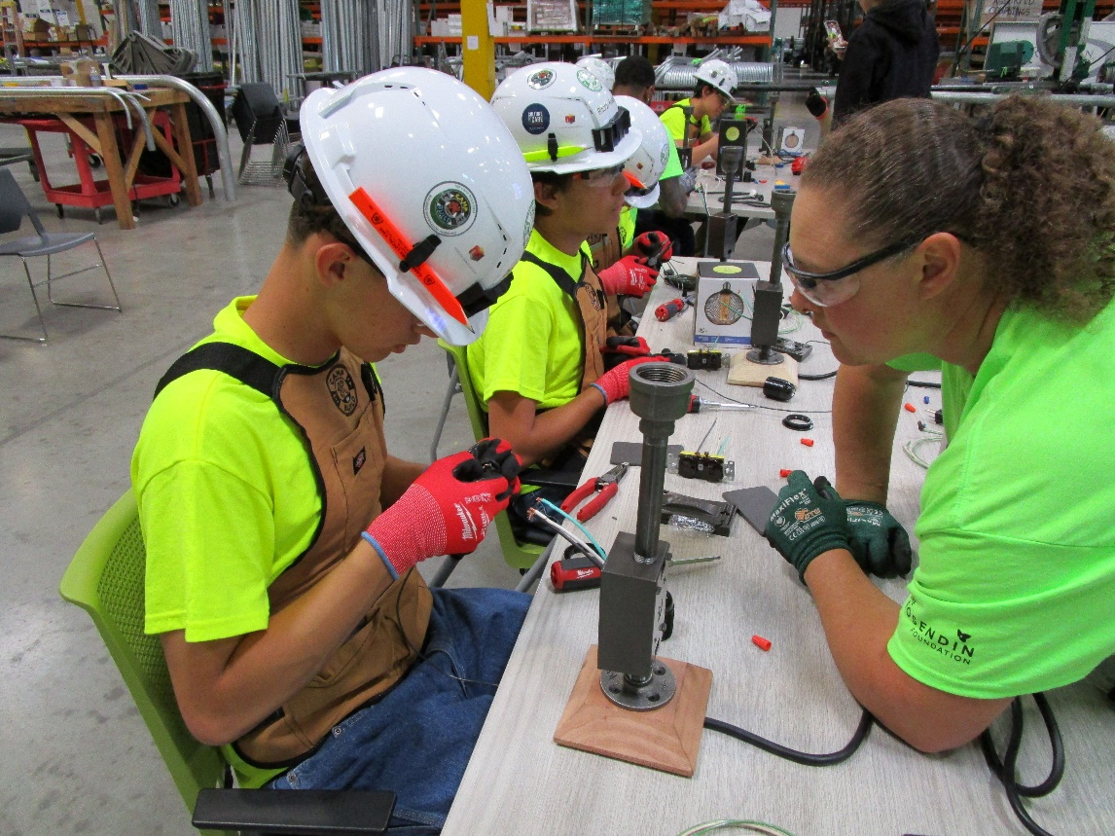
Tempe, AZ (June 13, 2023) – The Rosendin Foundation, a 501(c)(3) non-profit organization dedicated to positively impacting communities, building and empowering people, and inspiring innovation, is proudly sponsoring a free construction camp for 16 middle school students in Tempe, Arizona. From Monday, June 19 to Friday, June 23, TRF Camp Build aims to empower students to experience the excitement of hands-on building and gain new insights into the construction industry.
"Seeing the children's engagement, their keen interest in absorbing information, and active participation in the activities is exciting," said Jolsna Thomas, President of The Rosendin Foundation. "We are extremely proud to help inspire the next generation of builders."
Conducted at Rosendin's Arizona regional office, located at 1315 W. Drivers Way in Tempe, this FREE co-ed week-long day camp caters to rising 7th through 9th graders, offering them hands-on building experiences in which they learn to use power tools, build their own lamps, and engage in roofing and framing activities. The camp culminates in the construction of doghouses, which are then donated to a local nonprofit.
Throughout the camp, participants will hone essential skills such as safe tool usage and construction building, while exploring potential career avenues in the expanding construction industry under the tutelage of seasoned professionals. As part of the camp, the students will also take a field trip to the Mesa Data Center, one of the most advanced, energy- and water-efficient data center facilities in the world.
“From Arizona to Tennessee, Meta's Data Centers are excited to support the inaugural year of Camp Build alongside our partners at The Rosendin Foundation, as we support the industry's effort to help students in the East Valley gain knowledge and tools to explore career opportunities,” said David Williams, Community Development Manager at Meta. “This is a great opportunity to help ignite curiosity and create an appreciation for skilled trades, especially in data center construction and management."
TRF Camp Build will provide students with a safe and controlled environment to gain practical learning experience and explore diverse career possibilities in construction. This nonprofit event and four others held nationwide were made possible due to the generous support from sponsors and in-kind donors such as sister companies Rosendin and MPS, the Mesa Data Center, Milwaukee Tool, Stanley Black and Decker, Border States, Sundt, DPR Construction, UA 469, United Rentals, 10:1 Public Relations; Collinsworth, Specht, Calkins & Giampaoli, LLP; DMG AZ Homes Team Re/Max Solutions; Southland Industries; Ward Cornett & Associates, Arizona Painting Company and Arizona Carpenters Local 1912,
For more information about The Rosendin Foundation and its initiatives, visit www.therosendinfoundation.org.

About The Rosendin Foundation:
Rosendin Holdings formed The Rosendin Foundation in 2020 as a 501 (c)(3) charitable corporation to act as its charitable arm for which all charitable giving would be centralized or guided. This includes Rosendin Electric, Inc. (Rosendin) and Modular Power Solutions (MPS). Although the corporation is based in San Jose, California, The Rosendin Foundation provides funding to non-profit organizations across the United States. For more information visit www.therosendinfoundation.org

About Rosendin:
Rosendin, headquartered in San Jose, is employee-owned and one of the largest electrical contractors in the United States, employing over 8,000 people, with $3 billion in revenue. Established in 1919, Rosendin remains proud of our more than 100 years of building quality electrical and communications installations and value for our clients but, most importantly, for building people within our company and our communities. Our customers lead some of the most complex construction projects in history and rely on us for our knowledge, ability to scale, and dedication to quality. At Rosendin, we work to ensure that everyone can reach their full potential by building a diverse, safe, welcoming, and inclusive culture. For more information, visit www.rosendin.com.
###

Media Contact:
Salina Brown
Rosendin
480-477-1905
SBrown3@rosendin.com

Jolsna Thomas
The Rosendin Foundation
512-278-8497
Jolsna@therosendinfoundation.org

Michelle Bolden
10 to 1 Public Relations
480-363-5733
Michelle@10to1pr.com

