Viddy Awards Submission 2021
Mimecast
Category: Non-Broadcast | Short Form Web Videos < 3 Minutes | 241c. Training Module
Submission: Mimecast Security Awareness Training
Introduction: Mimecast Security Awareness Training (AT) helps organizations across all industries reduce security risks associated with employee human error. Developed by top leadership from the U.S. military, law enforcement, the entertainment industry and the intelligence community, Mimecast AT is a security awareness training and cyber risk management platform that helps organizations combat information security breaches caused by employee mistakes. Human error is involved in 90%+ of all cybersecurity breaches. Mimecast AT saves companies time and money by improving their human firewall and significantly reducing exposure that often results from employee carelessness and apathy.
Humor has been identified by experts as a clear way to engage people. Mimecast AT training modules feature creative, humorous content developed by entertainment industry professionals, in addition to the tactical security tests – like mock phishing emails. The content is delivered in small does (2-3-minute videos distributed monthly). Thanks to the relatable storyline and clever writing, employees remain engaged. The platform also collects great data on knowledge, behavior and sentiment – all indicators of human error risk. The data is then used to provide more training for the employees who need it, and less for those who are on top of things.
Cyber threats are increasing in sophistication and ransomware has affected countless organizations in recent months. Mimecast
AT helps employees keep their cyber hygiene sharp, avoiding bad clicks and errors caused by lack of knowledge. The videos cover various topics including phishing, password, privacy PII, PCI, HIPAA, Ransomware, CEO/Wire Fraud, Data in Motion, Office Hygiene, GDPR among others.
The results have been clear. This program dramatically increases employee knowledge of basic security issues and their ability to respond correctly. Our research found that employees from companies not using Mimecast AT were more than 5x more likely to click on Malicious links. Below please find supporting assets, and we have attached three example videos.

“Our firms’ Corporate Security Department has found the Mimecast training platform to be a very effective tool for developing, reinforcing and preserving security awareness. It’s unique method of presentation—being humorous and topical, while also poignant—is very effective. For the first time, we have staff looking forward to their security awareness training.”
- SVP, Corporate Security Structural Engineering Consulting Company – 1,500 employees

Key stats related to Mimecast AT

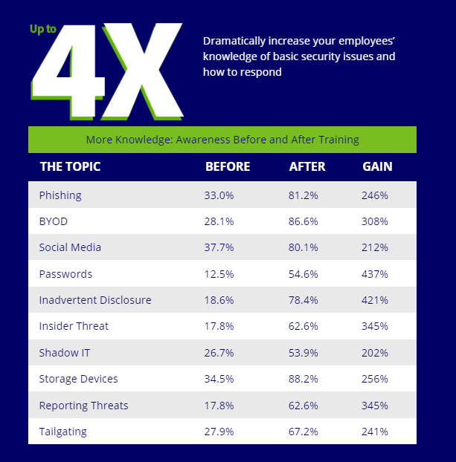
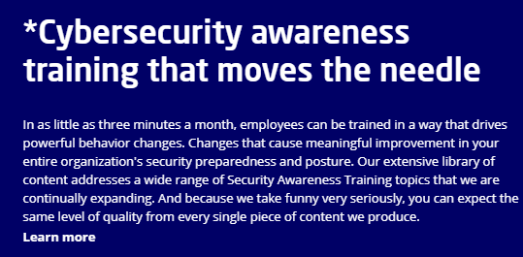
Main Characters of Mimecast AT
Mimecast AT uses professional actors and writers from the entertainment industry. At the core of the video are two characters that are funny and interesting, leading to users retaining the information presented! Here is a great overview of our two stars:
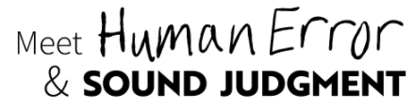
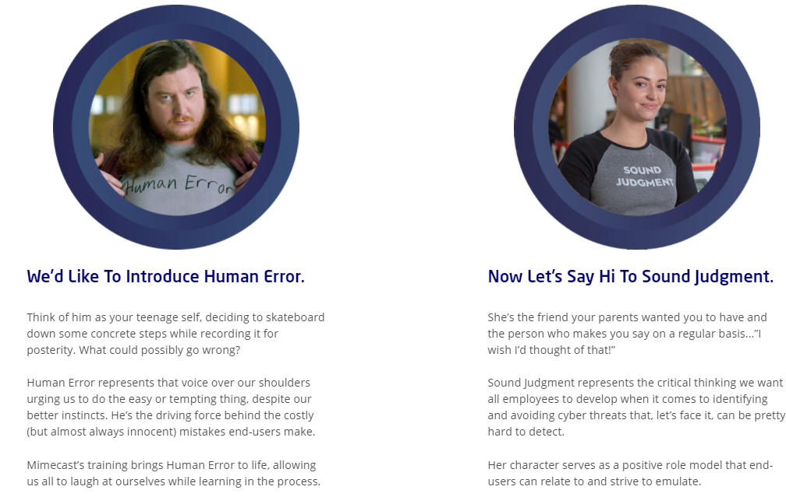
Supporting quotes: ““In the crowded field of cybersecurity training, Mimecast Awareness Training stands apart. Not only is the training content engaging (employees actually look forward to the next video), but their analytics enable a new and holistic approach to improve a company’s overall security culture. What we spend on Mimecast Awareness Training is probably our best spent security dollars—a foundational element in managing cybersecurity risk.” – William Hammersla, Chairman, Utilidata, Former CSO, Forcepoint, Former President, Raytheon Cyber Products.
“The move to the Mimecast AT solution has seen a huge improvement in our user adoption levels. Our staff really looks forward to the next monthly module. These modules are entertaining whilst always being educational ensuring that the underlying message is clear and concise. This solution was perfect for our global business, delivering the training in the local language." – CTO, in the Manufacturing Industry via Gartner Peer Insights

Supporting assets
YouTube – Mimecast AT Mini Module: Credential Harvesting
YouTube – Human Error speaks with Kelvin Coleman, Executive Director of the National Cyber Security Alliance, to celebrate National Cybersecurity Awareness Month
YouTube – Mimecast AT characters share their thoughts on staying safe while working from home
YouTube – Mimecast AT case study with the Geo Group
YouTube – Human Error on the street, Las Vegas
Whitepaper – Accessing Organizational Readiness to Deal with Increased Employee Cyber Awareness
Case Study – Massimo Zenetti Beverage
Full URL – Cybersecurity Training done right
Videos attached with submission
#1: “Example Mimecast AT episode from Season 5_ZOOM_VIDDY” - Here is one of our newer example videos from season five. End users at our customer organizations view these videos once a month. After the video there is a one question quiz that hits the theme of the episode. Data is retained and those who need more training will receive it. Previous season were mostly shot in office, but to keep up with training trends from the remote working era, this video was shoot over Zoom.
#2: “Example Mimecast AT episode from season 5_Animated_VIDDY” – Here is an example video from season five, this example shows one of our animated videos which end users receive in addition to the live action videos. Having different multimedia formats keep the end users engaged (and laughing) which helps them retain the information and stay cyber secure.
Thank you for your consideration!

