Graphic Copy (<20 words) | Social Media Post | File Name | SM Graphic
Through VA’s Million Veteran Program, Veterans can contribute their health and genetic data to research that will inform the future of medicine. | Veterans do not need to receive VA health care to join VA’s Million Veteran Program. Any Veteran can join online at www.mvp.va.gov. #VADidThat | VADT.March22.[PLATFORM].01.jpg | 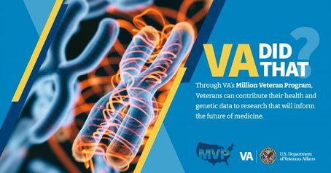
With 865,000+ Veterans enrolled to date, VA’s Million Veteran Program is one of the largest research programs in the world. | The genetic data from Veterans of all backgrounds allow researchers to identify differences in DNA that could lead to better care for Veterans. Learn more at www.mvp.va.gov. #VADidThat | VADT.March22.[PLATFORM].02.jpg | 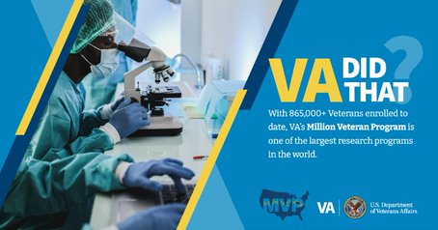
Thanks to nearly 150,000 Veterans of African ancestry in VA’s Million Veteran Program, VA has identified new genetic variants for a wide range of chronic diseases. | VA’s Million Veteran Program has more people of African ancestry enrolled than any other research program in the world. Learn more at www.mvp.va.gov. #VADidThat | VADT.March22.[PLATFORM].03.jpg | 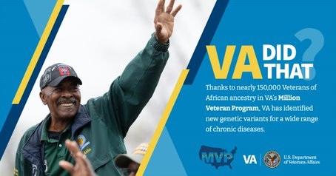
500+ researchers use data from VA’s Million Veteran Program to make groundbreaking medical discoveries. | These researchers work not only at VA, but also at some of the world’s most prestigious research institutions such as Harvard, Duke, and Stanford. Find out more at www.mvp.va.gov. #VADidThat | VADT.March22.[PLATFORM].04.jpg | 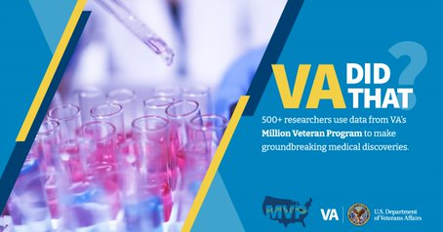
The largest genetic study on anxiety to date is of 200,000 Veterans in VA’s Million Veteran Program and it uncovered genetic markers that could indicate increased risk of anxiety. | This discovery may have implications for genetic risks across several psychiatric disorders. Find out more about the Million Veteran Program at www.mvp.va.gov. #VADidThat | VADT.March22.[PLATFORM].05.jpg | 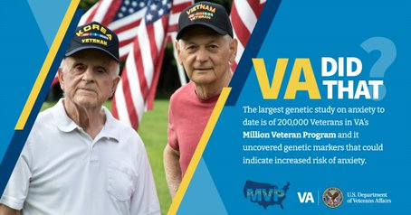
A 2019 study of more than 165,000 Veterans in VA’s Million Veteran Program found potential genetic links between PTSD and hypertension. | This means existing hypertension drugs could potentially be effective in treating PTSD. Learn more about the Million Veteran Program at www.mvp.va.gov. #VADidThat | VADT.March22.[PLATFORM].06.jpg | 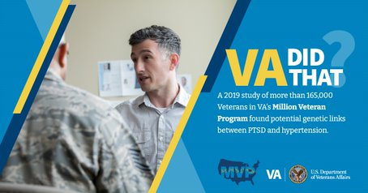
VA is on a mission to enroll 1 million Veterans to share their genetic and health information. This data will eventually allow VA to study nearly any kind of health condition affecting any Veteran. | We’re almost 90% there! Help us reach this important milestone and join the Million Veteran Program today! Find out more at www.mvp.va.gov. #VADidThat | VADT.March22.[PLATFORM].07.jpg

