
Contact: Alex Carpenter
Company: The Hoffman Agency
Address: 1201 NE Lloyd Blvd. Suite 730 Portland, OR 97232
Phone: 978-417-9457
Email: acarpenter@hoffman.com

The Hoffman Agency
Client: CASA for Children
Category: 301| Pro-Bono

Synopsis
When looking to expand our pro-bono program, the Hoffman Agency sought to identify organizations that were making a positive impact on the communities our teams were part of. The unique structure of the nonprofit meant there were branches available across the country, aligning with spread out groups of individuals.
With each operating independently of the other, we began our conversations with the CASA for Children (the Multnomah, Washington, Columbia and Tillamook Counties chapter), which quickly turned into a fruitful relationship for both parties.
At the time, they had just undergone staffing changes, leaving them with a one-woman communications team who had just begun her position with CASA. As such, we were able to offer support throughout the transition while simultaneously kicking off our own work. Since beginning our work with CASA back in November 2023, the Hoffman team has dedicated over 330 in-kind hours providing support across both traditional media relations and social media activities, ultimately providing an immense amount of value to their growing communications team.
Strategy and Execution
To begin the partnership between The Hoffman Agency and CASA for Children, Hoffman supported Portland's annual giving campaign — Give!Guide — held by local publication Willamette Week. This campaign is an annual effort to raise funds for, and draw attention to, the good works of local nonprofits in the Portland area, specifically targeting those under 35, which means there are many opportunities but also a lot of competition for donations.

From November 1 to December 30, 2023, Hoffman developed a total of 32 social promotions, including curated graphics, encouraging users to donate to CASA for Children.
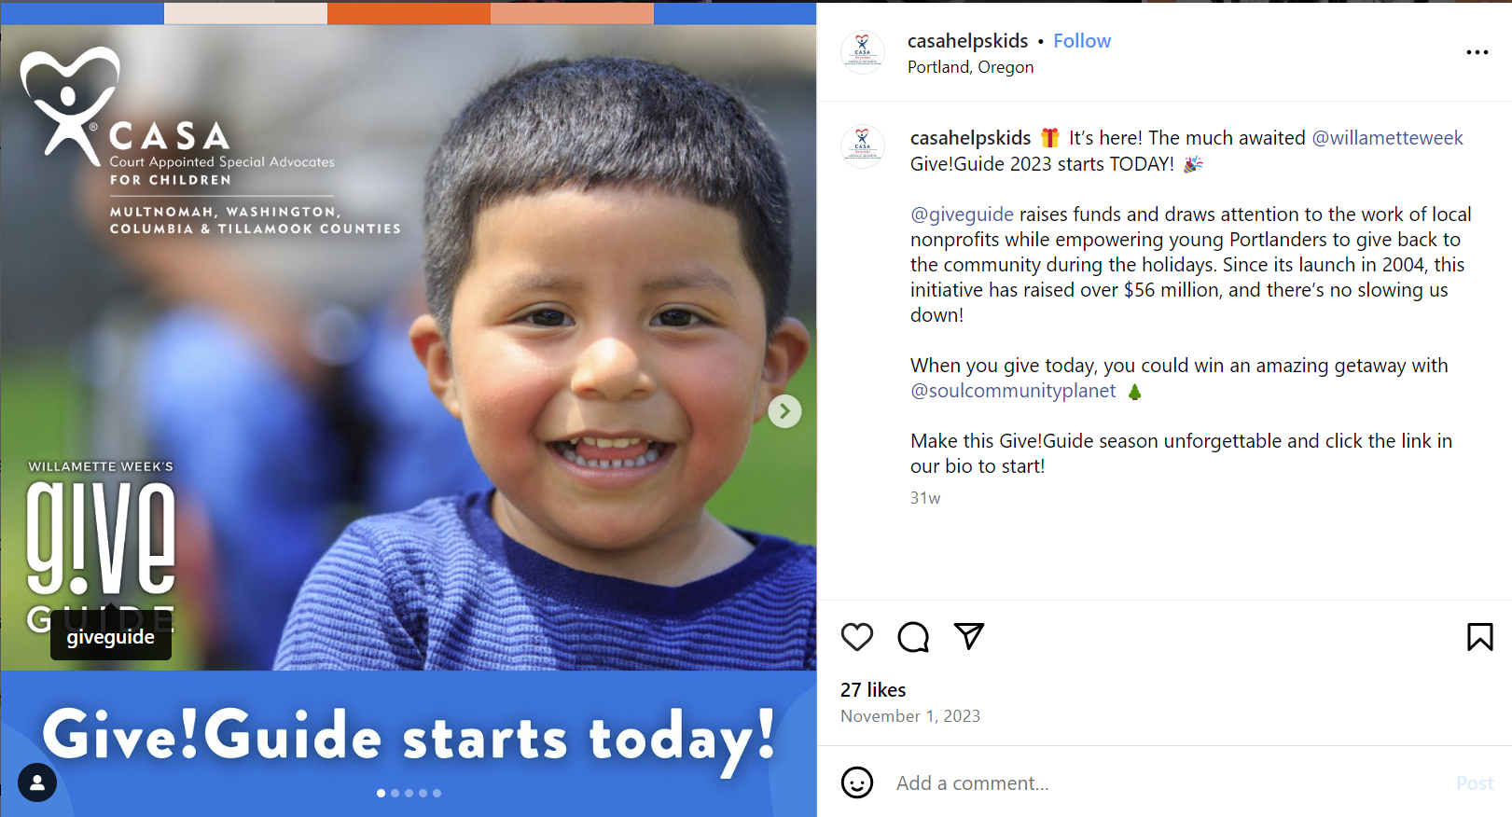
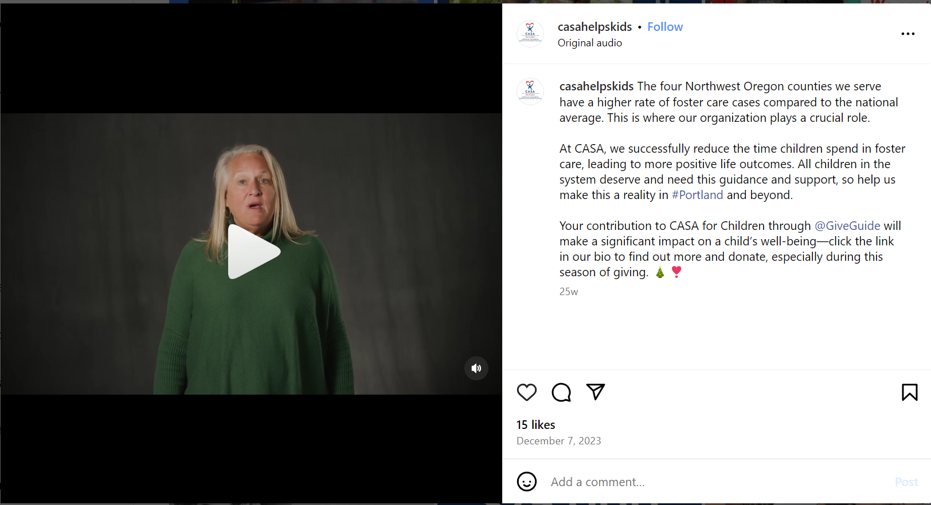
To raise awareness of CASA's impact beyond the annual giving campaign, the team also promoted important moments, including Small Business Saturday, Giving Tuesday, National Adoption Day, National Foster Care Day, Foster Care Awareness Month, National Volunteer Week and more. In addition to curating social posts for CASA's brand channels, the team included employee advocacy posts for CASA's community to share to their personal networks.
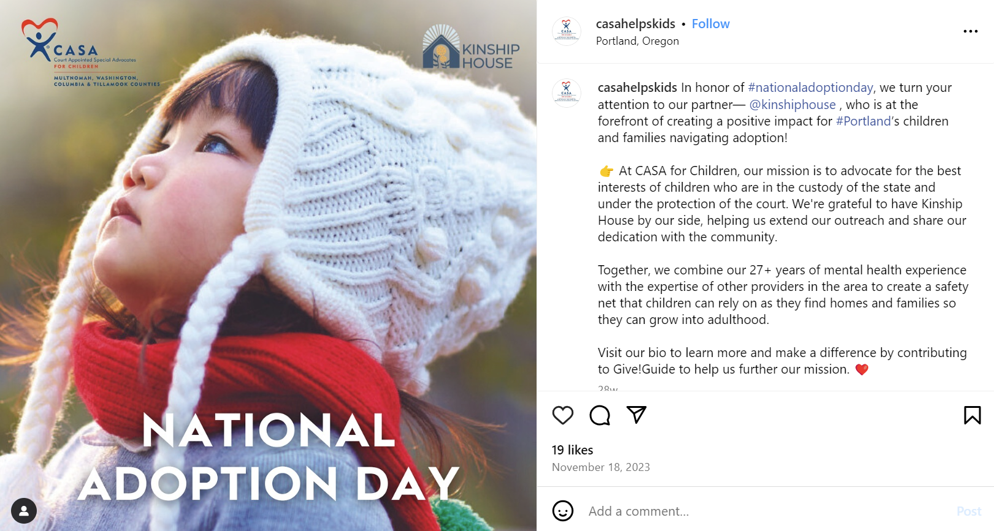
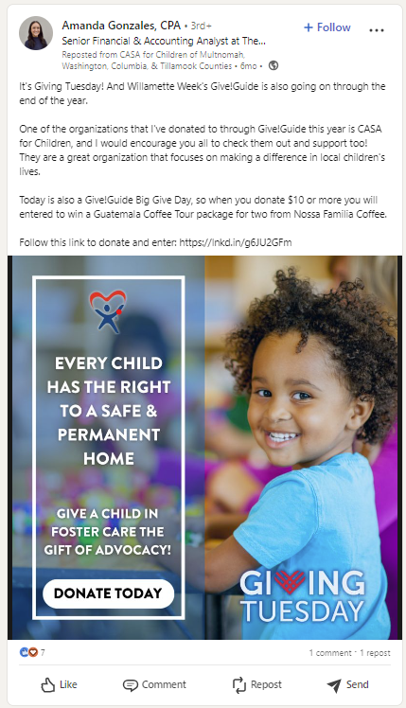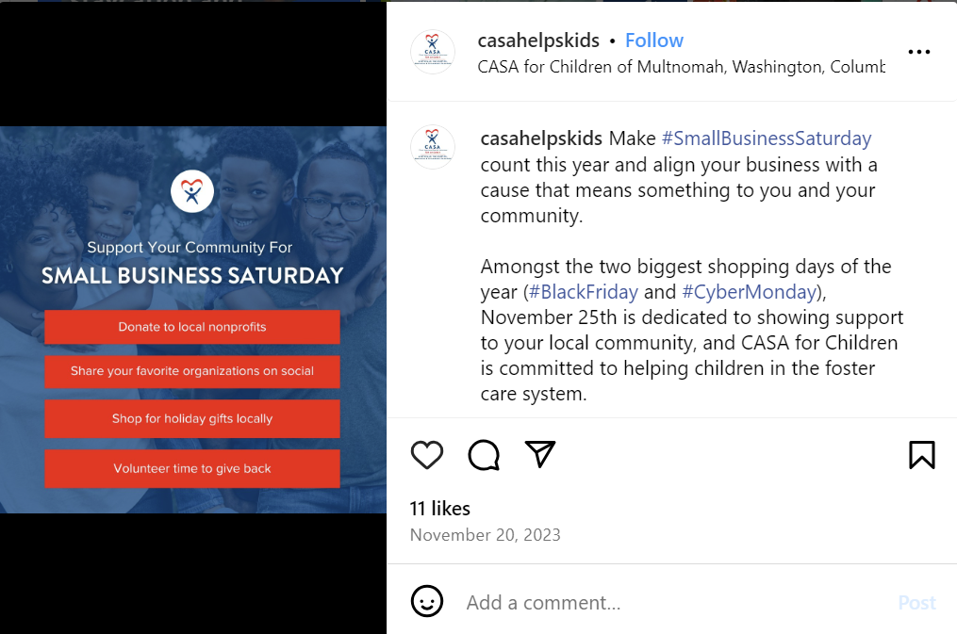

In Spring 2024, our team focused on promoting one of CASA’s largest fundraising events of the year, the CASA Cares Auction. To promote this event, we executed a mini-influencer program with a mix of in-kind Instagram story promotions and one paid Instagram Reel mention to encourage table sales, raffle tickets and donations, as well as to promote overall brand awareness for the important work that CASA does.
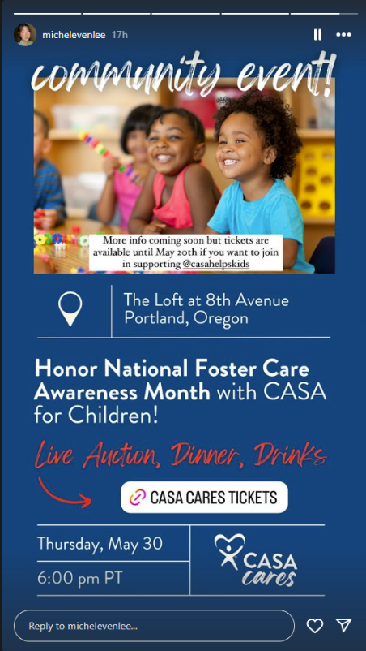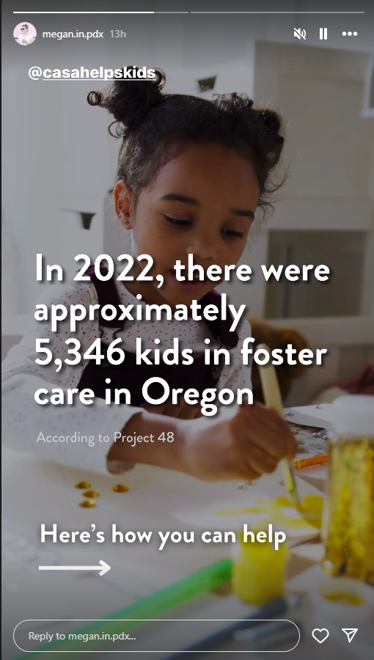

To further promote ticket sales, our team also pitched the event to local publications and event calendars, securing event listings in Willamette Week and PDX Mind Share.

Evaluation
The results of the Give!Guide in December included surpassing CASA's goal of $75,000 by reaching $77,900, with a total of 427 donations, in part due to our consistent drumbeat of organic social media posts during November and December.
Shifting to the influencer campaign we executed to support the CASA Cares Auction, @michelevenlee (78.4K followers) shared the auction flyer with a link sticker, a mention in a Reel that was reposted on TikTok and included the website link in the Linktree in her bio. Furthermore, @megan.in.pdx (18.7K followers) shared both the auction flyer with a link sticker and a video clip (see screenshots attached).
Our influencer efforts gathered a total of 40,260+ impressions, with an average engagement rate of 5.2% across Instagram and TikTok (much higher than the average influencer engagement rate of 1-3% on Instagram).
Due to our influencer efforts, organic social posts, local calendar listings and more, CASA raised just over $325,000 at this year’s CASA CARES Auction, up from $288,000 in 2023.
The cherry on top of our six months working with CASA? This enthusiastic kudos from CASA for Children’s Executive Director Betsy Stark Miller:

“I wanted to thank you again for all that you are doing for us and for the children we serve. The more messaging that gets out there, the stronger we become in our ability to serve all children. Your messaging has been spot on and so reflective of what we want people to know about our mission and foster care in Oregon. This is just incredible work, and we appreciate it so much.”

