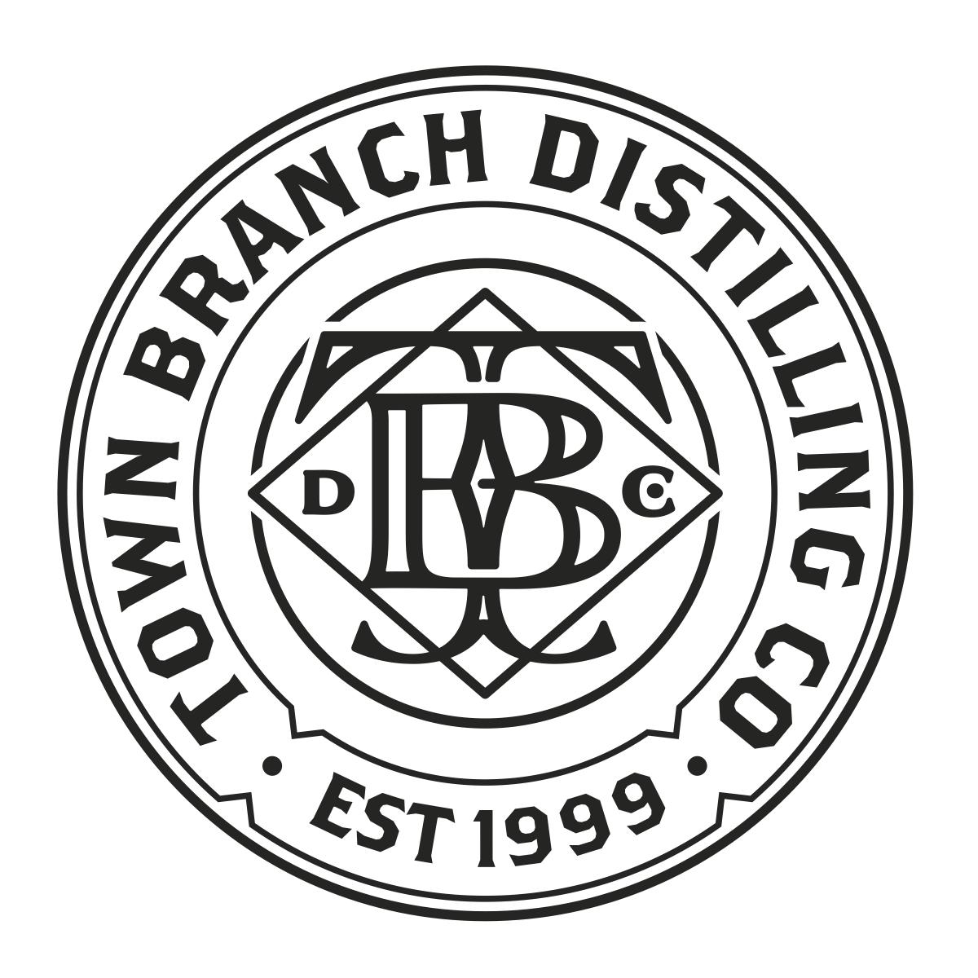

Media Contacts:
Hanna Lee / Nicole Schubert
Hanna Lee Communications, Inc.
646-752-1526 (cell) / 212-527-9969 (office)
hanna@hannaleecommunications.com
nicole@hannaleecommunications.com

FOR IMMEDIATE RELEASE

Town Branch Distillery, Lexington, Ky.’s First Distillery Since Prohibition,
Announces “Mint Julep Nation” to Salute the 2021 Kentucky Derby

13 Top Bartenders Across the U.S. Honor This Classic Cocktail with Hometown Inspirations, from New York to Los Angeles, Las Vegas to Nashville, Austin to Chicago

LEXINGTON, Ky., April 7, 2021—Town Branch Distillery, the first distillery to open in Lexington, Ky. since Prohibition, today announces “Mint Julep Nation,” a bartender campaign to salute the 147th running of the Kentucky Derby, “The Greatest Two Minutes in Sports.” Town Branch collaborated with 13 top bartenders across the U.S., who developed original Mint Julep variations with Town Branch®️ Bourbon (SRP $36.99/750ml) that pay homage to their hometowns and other inspirations.

A Unique Bourbon to Power Unique Mint Juleps
Town Branch®️ Bourbon has been embraced for its cocktail versatility by leading craft bartenders from coast to coast. On the nose, it beckons with pleasant woody and oaky notes, with a touch of baked apple and cinnamon. On the palate, a rush of lavish and complex notes of caramel, toffee, brown sugar and hints of cherry and baking spices, with a touch of corn sweetness in the background. Double distilled in pot stills, Town Branch®️ Bourbon is a blend of whiskeys at least 4 years old.

A Time-Honored Cocktail Synonymous with the Kentucky Derby
The Mint Julep is a time-honored cocktail made with Bourbon, sugar, mint and crushed ice served in a frosted julep cup of silver or pewter. It has been the official drink of the Kentucky Derby since 1939. Each year, almost 120,000 Mint Juleps are consumed at the annual race, tapping an estimated 10,000 bottles of spirit, 1,000 pounds of freshly harvested mint and 60,000 pounds of ice.

“The beauty of the Mint Julep is its simplicity,” says Tony Abou-Ganim, a Master Mixologist based in Las Vegas. “It offers a timeless template, a blank canvas as it were. The Mint Julep beckons the artistry of bartenders to give it their own interpretations, while not straying too far from its cherished roots. It is the ultimate in refreshment.”

13 Top Bartenders and Their Unique Mint Julep Inspirations
- Austin, Texas (Brett Esler, Idle Hands/Armadillo Den)
  - Texas Julep - A nod to the “World Famous Peach” stands of Texas Hill Country with its use of black-peach tea
- Chicago (Carley Gaskin, Hospitality 201)
  - Back to the Track Julep - Replaces sugar with honey and adds grapefruit for bright acidity to complement Chicago cold winters and beautiful summers
- Clayton, North Carolina (Sharfiq Cosby, Revival 1869)
  - Vital Roots - A fruit-forward spin that gives proper credit to the enslaved African American bartender, John Dabney, whose Hail Storm Mint Julep became the blueprint for the drink
- Dublin, Ohio (Rebecca Monday, Vaso at the AC Hotel Columbus)
  - One Mint Julep - Named for a Ray Charles song, it incorporates housemade Charred Orange Cordial and yuzu liqueur as Ohioans seek spring and summer flavors
- Fort Lauderdale, Florida (Pete Sierwuk, The Dalmar)
  - ...And Miami On The Inside - A tropical take that tips its hat to South Florida’s Cuban community and its pastelitos (guava pastries)
- Las Vegas (Tony Abou-Ganim, Modern Mixologist)
  - Apricot Julep - A flavorful rendition that incorporates fresh apricot slices and apricot liqueur
- Los Angeles (Sarah L.M. Mengoni, Kimpton Hotels & Historically Drinking)
  - Best Coast Julep - Honors Los Angeles’ health culture by using mango kombucha
- Madison, Wisconsin (Daniel Dufek, Shanghai Speakeasy)
  - Early Spring Julep - A reinterpretation of the Mint Julep by way of the Wisconsin Old-Fashioned, with pomegranates subbing in for cherries
- Nashville, Tennessee (Freddie Sarkis, Liquor Lab)
  - Julep Old-Fashioned - A Julep-inspired twist on the Old-Fashioned for whiskey-loving Nashville
- New York (Anthony Baker, “Professor Baker”)
  - The Mint Chocolate Julep - Adds crème de cacao liqueur in homage to mint chocolate ice cream
- New York (Lucinda Sterling, Middle Branch and Seaborne)
  - The Stretch Runner - Brings a new level of flavor complexity with the addition of cherry liqueur, ginger syrup, as well as shiso and anise hyssop leaves, with New York State applejack adding a local flavor
- Sylva, North Carolina (Antoine Hodge, The Wine Bar & Cellar)
  - Mountain Honey Julep - An ode to local mountain orange blossom honey from North Carolina
- Washington, D.C. (Deke Dunne, Allegory at the Eaton DC Hotel)
  - No Kings - Saluting Washington, D.C.’s graffiti culture, it swaps in a local cherry blossom bitter liqueur as its sweetener and uses Peychaud’s Bitters as a sprayed garnish

“There are few cocktails as cooling, delightful and imbued with tradition and history as the Mint Julep,” says Lucinda Sterling, Head Bartender & Owner, Middle Branch and Seaborne in New York. “While spirit and mint are non-negotiable parts of its DNA, there has always been some latitude to improvise and embellish it in new variations. Beyond Derby Day, it is a stellar cocktail that lets drinkers laugh at hot and humid weather any time.”

Recipe #1: Texas Julep
by Brett Esler, Idle Hands/Armadillo Den (Austin, Texas)
2 oz Town Branch Bourbon
.5 oz Black-Peach Tea Syrup*
6-8 mint leaves (muddled)

Add 6 to 8 mint leaves and black-peach tea syrup to a Julep cup and muddle together gently. Pour in Town Branch Bourbon and give a quick stir to integrate. Then add crushed ice (or Sonic ice) to the top of the glass and stir a few times until ingredients are properly mixed together. Finish by adding a few healthy mint sprigs poking out of the glass, then sprinkle with powdered sugar, and enjoy!

*Black-Peach Tea Syrup
2 cups water
1 black-peach tea bag (10g)
2 cups sugar
Bring water to a boil, turn off heat, add the tea bag and let it steep for 10 minutes. Strain and add equal parts sugar.

Inspiration:
“Just outside of Austin, in the Texas Hill Country, you’ll often see ‘World Famous Peach’ stands peppered everywhere in the sweltering summer heat. And if you’ve ever pulled over to the side of the road to indulge, it’s easy to understand why. It's also no secret how quenching a proper Mint Julep can be in said summer heat. So what better way to cool off by marrying the two together in this refreshing Julep riff with Town Branch Bourbon.”

Recipe #2: Back to the Track Julep
by Carley Gaskin, Hospitality 201 (Chicago)
2 oz Town Branch Bourbon
1 tsp. honey
1 grapefruit slice
6 mint leaves

Add mint, grapefruit and honey to a Julep cup and lightly muddle. Add Town Branch Bourbon and crushed ice. Garnish with a mint sprig and dust with cinnamon.

Inspiration:
“Chicago has two seasons, the bitter cold winters and the absolutely gorgeous summers. I wanted to create a delicious Julep that could be enjoyed not only during Derby Season, but year-round! The honey adds a beautiful texture that pairs perfectly with the bright acidity of grapefruit and, of course, Town Branch Bourbon.”

Recipe #3: Vital Roots
by Sharfiq Cosby, Revival 1869 (Clayton, North Carolina)
2 oz Town Branch Bourbon
.25 oz Aperol
2 full droppers chocolate bitters (Bittermens Chocolate Mole Bitters is preferred)
1 barspoon Demerara syrup
1 barspoon fine sugar
1 barspoon orange marmalade (local, if available)
6-8 mint leaves

Lightly press the mint with all the ingredients in a Julep cup. Stir briefly, then fill the cup halfway with crushed ice. Swizzle, then top off with more crushed ice. Garnish with a mint bouquet, a candied orange slice (homemade or store bought) and cocoa powder.

Inspiration:
“My inspiration for this cocktail is a guy named John Dabney. As an African American bartender myself and I’m pretty sure many others wondered if any of these classic cocktails were invented by our own and if not invented, then popularized somehow. The Mint Julep is one of those cocktails. John Dabney was a African American slave from Virginia and his ‘Hail Storm’ Julep is the blueprint for Mint Juleps, in my opinion. Aesthetically and factually, this can’t be denied and anyone can fact check me on that. Mr. Dabney ushered in the use of crushed ice with the ‘Hail Storm,’ and this since then has been vital to Mint Juleps because, as the ice dilutes, the drink becomes more complex. I always say to myself, ‘If you're going to be anything, be vital’ and I believe John Dabney was just that to cocktail culture.”

Recipe #4: One Mint Julep
by Rebecca Monday, Vaso at the AC Hotel Columbus (Dublin, Ohio)
2 oz Town Branch Bourbon
.5 oz Charred Orange Cordial*
.5 oz yuzu liqueur

Add all ingredients into a shaking tin. Add ice and lightly shake the cocktail. Double-strain over crushed ice in a Julep cup. Garnish with a sprig of lemon verbena and a mint sprig, with an orange twist next to the herbs.

*Charred Orange Cordial
1 orange
1 spoon citric acid solution (10:1 water:citric acid)
5 mint leaves

Cut a whole orange in half and top with brown sugar. Char both sides on the grill. Juice the whole orange. Double-strain juice. Take equal parts charred orange juice to sugar and dissolve sugar on low temperature heat. Add a spoon of citric acid solution. Remove from heat and let 5 mint leaves steep for 10 minutes. Chill in the fridge overnight.

Inspiration:
“My cocktail’s name was inspired by the song ‘One Mint Julep’ by Ray Charles. As seasons turn in Ohio from winter to spring and summer, I find that Ohioans are in search of spring breaks straight into summer flavors. While making the One Mint Julep, I was able to combine spring and summer flavors of sweet oranges, methods of grilling and charring, as if in a backyard get together, bright yuzu notes, and fresh mint to round out the cocktail, all while highlighting Town Branch Bourbon and giving homage to the classic Mint Julep. Vaso transitions with seasons as we are an outdoor rooftop bar and our community joins us in this transition by getting excited to sit outside and watch the beautiful sunset views. This cocktail was inspired by that season transition with a culinary twist.

Recipe #5: ...And Miami On The Inside
by Pete Sierwuk, The Dalmar (Fort Lauderdale, Fla.)
1.75 oz Town Branch Bourbon
.5 oz Cognac
1 oz Guava Mint Syrup*

Combine all ingredients in a Julep cup and top with pebble/crushed ice. Garnish with a bouquet of mint sprigs. Sit back and sip slowly.

*Guava Mint Syrup
1 part guava nectar
1 part white sugar
.5 lbs fresh mint, lightly beaten to release the oils
Combine guava nectar and white sugar in a blender and blend until the sugar is dissolved, about 90 seconds. Then take the mint and place it in the container with the guava syrup and let it rest 8 to 24 hours in the fridge. Strain out the mint leaves and bottle for up to one week.

Inspiration:
The inspiration for this drink comes from a mix of those quirky names, the energy of hearing them called out with your race ticket clutched in one hand while holding an ice cold, refreshing Julep in the other. The feeling of excitement and adrenaline paired with refreshing mint, Bourbon and guava. Two of the best things about South Florida are the sunny days and the Cuban food. So I wanted to pair two of my favorite flavors from this combo: mint and pastelitos (or Guava pastries). The combination is refreshing, tropical, and with every sip makes you long for the sunny, beach-filled days hopefully with a winning race ticket in your hand.

Recipe #6: Apricot Julep

by Tony Abou-Ganim, Modern Mixologist (Las Vegas)
1.5 oz Town Branch Bourbon
.5 oz Marie Brizard Apry Liqueur
1 oz simple syrup
10-12 fresh spearmint leaves
3 slices fresh apricot

Place the fresh apricot slices and mint leaves into a Julep cup, add simple syrup and gently muddle with a wooden muddler. It is very important to muddle just enough to release the oils without tearing or bruising the mint. Next, fill the cup with crushed ice, add Town Branch Bourbon and Marie Brizard Apry, and stir to mix. Top the cup with crushed ice and stir until a frost forms on the outside of the cup. Garnish with a sprig of fresh mint and add a straw to serve.

NOTE: Serve linen napkins with the Juleps to keep guests from feeling the chill.

Inspiration:
“The Mint Julep is a creation that brings wisdom to fools, turns wallflowers into the life and soul of the party, makes the clumsy graceful, the weak strong, and brings sophistication and charm to the most ill-mannered lout.” —Gary Regan, “The Book of Bourbon”

Recipe #7: Best Coast Julep
by Sarah L.M. Mengoni, Kimpton Hotels & Historically Drinking (Los Angeles)
1.5 oz Town Branch Bourbon
2.5 oz mango kombucha (GT brand, widely available, is recommended)
.5 tsp white granulated sugar
2 swaths lime peel
half a lime, hollowed out

Trim the lime shell to look like a palm tree, make a hole in the end and put a straw through it (metal straws work perfectly!). Add sugar and lime swaths into a Julep cup and stir. Combine with 1 oz of the kombucha and stir until the sugar dissolves. Add remaining kombucha (1.5 oz) and Town Branch Bourbon. Fill the cup 3/4 full with crushed ice and stir until the cup has a nice thick frosty coating on the outside. Top with more crushed ice. Give it a few more stirs and insert the palm tree straw. Get stoked, ‘cause this cocktail is legit.

Inspiration:
“In making this Los Angeles-inspired version of a Mint Julep, I chose to use kombucha as a nod to the cult of health here in L.A. It’s the place where health food trends start, are propagated and become part of the identity of the city. The mango in the kombucha plays deliciously well with the toasty barrel aromas in the Town Branch Bourbon and reminds me of the Mexican fruit carts that are all over the city. The aromatics and visual appeal of mint in the classic Mint Julep are so important, and I wanted to recreate that effect. As SoCal is known for its citrus, lime was the perfect replacement. The aromatics from the oils in the peel add a subtle layer of complexity to the drink, and the palm tree garnish smells great and looks like a day at the beach. As it should, the Town Branch Bourbon shines in this cocktail like the sun does every day in L.A.”

Recipe #8: Early Spring Julep
by Daniel Dufek, Shanghai Speakeasy (Madison, Wisc.)
2 oz Town Branch Straight Bourbon
.5 oz Early Spring Old Fashioned Syrup*
12-14 fresh mint leaves

Lightly muddle the mint in half of the syrup. Add Bourbon, then fill with crushed ice.
Stir until the outside of glass frosts. Top with more crushed ice so it mounds on top like a snow cone. Pour the remaining syrup over the ice. Garnish with two dried orange half-wheels, dried pomegranate arils, a large, smacked mint bouquet and powdered sugar.

*Early Spring Old Fashioned Syrup
1 cup pomegranate juice
1 cup superfine sugar
2 oz pomegranate molasses
1 oz Angostura Bitters
1 peel of a whole navel orange

Muddle peels gently in a glass infusion jar, then add the remaining ingredients. Stir until sugar is dissolved. Cover and let sit at least two hours and up to overnight. Strain peels out, then bottle and refrigerate.

Inspiration:
“This cocktail is sort of a love letter to both the Wisconsin Old Fashioned and a Julep. I love and hate both cocktails dearly. :) When they’re done well, they’re great and distinctive cocktails. When done poorly, they're pretty terrible. I’ve done Old Fashioned builds before where I incorporate the muddled cherry and orange (that is so popular across Wisconsin) into a compound simple syrup so it can still be executed like a traditional Old Fashioned (spirit, sugar, bitters, water). This drink uses a syrup that is based on that same idea. However, as a nod to this particular transitional season we’re in now, I’ve swapped out the cherry for pomegranate, and then utilized it here in place of the traditional simple syrup (or sugar) of a Mint Julep. It’s fruity, but still whiskey forward, and the bitters and acidity of the pomegranate molasses are a really nice foil for the sweetness of the sugar and mint.”

Recipe #9: Julep Old Fashioned
by Freddie Sarkis, Liquor Lab (Nashville, Tenn.)
2 oz Town Branch Bourbon
.25 oz Demerara syrup (2:1 Demerara sugar to water)
2 dashes Angostura Bitters
1 spearmint tea bag

Infuse Town Branch Bourbon with a spearmint tea bag for 3 minutes, pressing on the tea bag after removing. Combine ingredients in a rocks glass and stir with large ice cubes until ice cold. Garnish with a sprig of fresh mint.

Inspiration:
“Nashville is a city that loves whiskey, the ones made not far from here and the ones made just a little ways north. Giving a little Julep-inspired twist to a year-round favorite mixes it up and still keeps it simple enough that anyone can easily enjoy it in their own home without much fuss.”

Recipe #10: The Mint Chocolate Julep
by Anthony Baker, “Professor Baker” (New York)
1.5 oz Town Branch Bourbon
.75 oz crѐme de cacao liqueur
12 mint leaves
6 dashes Angostura Cocoa Bitters

Pluck mint leaves and put them into a shaker, but do not muddle. Add Town Branch Bourbon, crѐme de cacao liqueur and bitters. Add one large ice cube and shake hard for 10 seconds. Strain into a Julep cup. Top with crushed ice and garnish with a chocolate candy and a mint bouquet.

Inspiration:
“This is a typical Mint Julep recipe with a small twist. I added chocolate flavor using crѐme de cacao liqueur, which may remind drinkers of mint chocolate ice cream. I felt this was the perfect opportunity to mix these two commonly married flavors together using fresh mint instead of the usual crѐme de menthe.”

Recipe #11: The Stretch Runner
by Lucinda Sterling, Middle Branch and Seaborne (New York)
1.5 oz Town Branch Bourbon
.75 oz Ginger Syrup*
.5 oz Cherry Heering Liqueur
6 to 8 fresh shiso leaves
6 to 8 anise hyssop leaves
10-15 fresh spearmint leaves
.5 oz applejack (New York State preferred), float

Muddle the fresh leaves with ginger syrup and Cherry Heering in a Julep cup, only pressing down firmly 3 or 4 times, until the ingredients are integrated. Do not overmuddle! Add about a half-cup pebble or crushed ice. Use a metal spoon to push the fresh leaves to the bottom. Add more crushed ice to the Julep cup. Pour in Town Branch Bourbon. Top with more pebble or crushed ice to form a mound atop the Julep cup. Top with applejack. Garnish the inside of the Julep cup with 3 to 4 fresh mint sprigs for a special olfactory sensation.

*Ginger Syrup
8 oz fresh ginger juice
6 oz granulated sugar

Combine fresh ginger juice extracted from a cleaned and grated ginger root and granulated sugar into a tall measuring cup. Blend well until sugar is fully dissolved.

Inspiration:
“My inspiration for The Stretch Runner was cherry liqueur, light and zesty in flavor, yet complementary to the oak and vanilla in the Bourbon. With so many great applejacks hailing from New York, I thought it would be a great partner with the caramel notes in the Town Branch.”

Recipe #12: Mountain Honey Julep
by Antoine Hodge, The Wine Bar & Cellar (Sylva, North Carolina)
2.5 oz Town Branch Bourbon
.5 oz Orange Blossom Mountain Honey Syrup* (2:1 honey to water)
16-20 mint leaves

Add orange blossom honey syrup and mint leaves to a Julep cup. Gently bruise the mint with a wooden muddler to release the mint oil. Add Town Branch Bourbon and stir the mixture. Reserve a half-ounce of the mixture for later use. Add a scoop of crushed ice and stir the drink 25 turns with a spoon or swizzle for 20 seconds. Add more crushed ice, mounding it into a compact dome. Garnish with the prettiest mint from the bunch, and pour the reserved half-ounce of the mixture over the top of the crushed ice dome to “season” the ice and mint. Enjoy.

*Orange Blossom Mountain Honey Syrup
2 oz orange blossom mountain honey
1 oz hot water
Combine honey and hot water to make the syrup. Set aside to cool.

Inspiration:
“I am currently in Sylva, North Carolina working at The Wine Bar & Cellar and opening a rustic Southern Italian restaurant called Ilda. I chose to use mountain honey instead of simple syrup, not to disrespect the original Julep recipe, but to incorporate the amazing local ingredients I have in my reach and use them to reinterpret a Derby classic!”

Recipe #13: “No Kings”
by Deke Dunne, Allegory at the Eaton DC Hotel (Washington, D.C.)
1.5 oz Town Branch Bourbon
1 oz Don Ciccio & Figli Cerasum Aperitivo
8 mint leaves
Peychaud’s Bitters, sprayed

Combine all the ingredients and 8 leaves of mint in a Julep glass and muddle. Top with crushed ice. Place Peychaud’s Bitters in an atomizer and spray the crushed ice like it is spray paint. Garnish with a sprig of mint and a metal straw.

Inspiration:
“Washington, D.C. has a rich history of graffiti art, from the legendary graffiti artist Cool Disco Dan in the ‘70s and ‘80s to the more recent iconic murals and pop-ups of the No Kings Collective. In order to pay homage to a criminally underappreciated art scene, I give you the ‘No Kings.’ No Kings is a Julep variation made with Town Branch Bourbon, which has notes of mint and cherry, and I combined it with Washington D.C.’s very own Don Ciccio & Figli Cerasum Aperitivo, a juicy, cherry blossom bitter liqueur. I then combined those ingredients with fresh mint and Peychaud’s Bitters, which has notes of cherry and anise. The spraying of the bitters is a representation of the amazing street art pioneers that spanned generations in Washington, D.C.”

About Town Branch Distillery
Located in Lexington, Ky., Town Branch is the city’s first distillery to open since Prohibition. It crafts the award-winning Town Branch®️ Bourbon, Town Branch Rye®️, Town Branch Malt®️ and Bluegrass Sundown®️, a Bourbon-infused coffee liqueur. Town Branch Distillery is the only distillery on the Kentucky Bourbon Trail®️ to double distill all of its spirits in copper pot stills. It is one of a handful of distilleries to be co-located with a brewery, the Lexington Brewing Co., which crafts a range of beers, including its flagship brew, Kentucky Bourbon Barrel Ale®️, thanks to its proximity to fresh Bourbon barrels. The two companies were founded by Dr. Pearse Lyons, a visionary Irish entrepreneur and scientist, who also founded Alltech, an agro-food pioneer focused on yeast fermentation, enzyme technology and nutrigenomics. For more information, please visit https://www.lexingtonbrewingco.com/products/town-branchr-bourbon, follow us on Twitter at @TownBranch_KY and Instagram at @townbranchbourbon.

# # #

